

CYBERSENTINEL XDR: NETWORK INTRUSION SIMULATION

A CAPSTONE PROJECT REPORT

A Capstone Project Report submitted in partial fulfilment of the requirements for the Course of

CSA6001 - Cybersecurity Incident Handling and Response

to the award of the degree of

BACHELOR OF ENGINEERING IN
COMPUTER SCIENCE AND ENGINEERING (CYBERSECURITY)

Submitted by
Vickramabharathi V (192465069)
Ram Prasath J (192565021)
Abinesh M (192465050)
Dhanushkumar R (192565087)

Under the Supervision of Dr. Dr. Sriramakrishnan G V
SIMATS ENGINEERING
Saveetha Institute of Medical and Technical Sciences Chennai-602105

SEPTEMBER 2026

SIMATS ENGINEERING
Saveetha Institute of Medical and Technical Sciences Chennai-602105

BONAFIDE CERTIFICATE

This is to certify that the Capstone Project entitled “CyberSentinel XDR: AI-Powered Network Intrusion Simulation & Threat Detection Engine” has been carried out by Vickramabharathi V (192465069), Ram Prasath J (192565021), Abinesh M (192465050) and Dhanushkumar R (192565087) under the supervision of Dr. Sriramakrishnan G V and is submitted in partial fulfilment of the requirements for the current semester of the B.E. Computer Science and Engineering (Cybersecurity) program at Saveetha Institute of Medical and Technical Sciences, Chennai.

COURSE COORDINATOR COURSE FACULTY
Dr. G. V. Sriramakrishnan, Dr. G. V. Sriramakrishnan,
Professor Professor
Computational Intelligence Computational Intelligence
SIMATS Engineering, SIMATS Engineering,
SIMATS, Chennai – 602105. SIMATS, Chennai – 602105.

SIMATS ENGINEERING
Saveetha Institute of Medical and Technical Sciences Chennai-602105

DECLARATION

We, Vickramabharathi V (192465069), Ram Prasath J (192565021), Abinesh M (192465050) and Dhanushkumar R (192565087) of the Department of Computer Science and Engineering (Cybersecurity), SIMATS Engineering, Saveetha Institute of Medical and Technical Sciences, Chennai, hereby declare that the Capstone Project Work entitled “CyberSentinel XDR: AI-Powered Network Intrusion Simulation & Threat Detection Engine” is the result of our own bonafide efforts. To the best of our knowledge, the work presented herein is original, accurate, and has been carried out in accordance with the principles of engineering ethics and academic integrity. All sources, references, data, and other materials used in the project have been appropriately acknowledged. We further declare that the data, results, analysis, and findings presented in this report have not been fabricated, falsified, or manipulated. Any external tools, software, datasets, computational resources, or AI-assisted tools used during the project have been appropriately disclosed. We confirm that all applicable ethical, academic, institutional, and professional requirements have been duly followed throughout the planning, execution, analysis, and documentation of the project.

Place: SIMATS ENGINEERING
Date:

Signature of the Students with Names

SIMATS ENGINEERING
Saveetha Institute of Medical and Technical Sciences Chennai-602105

Individual Contribution Statement

Student Name / Register No. | Specific  Responsibilities | Design & Development Contribution | Testing & Analysis  Contribution | Report Contribution | Approx.  Contribution (%)
Vickrama  bharathi  (192465069) | Attack Simulation Engine design; DDoS, Port Scan & Brute Force modules | DDoS Saturation, Port Reconnaissance and Brute Force attack simulators | Validated attack traffic generation and detection scoring f | Chapter 3 (Design), Chapter 4 (Module 1) | [25%]
Ramprasath (192565021) | Detection Rule Engine & real-time scoring logic | Weighted rule-based Detection Engine | Detection accuracy and confidence testing | Chapter 3 (Detection Design) | [25%]
Abinesh M  (192465050) | Real-time pipeline: Socket.IO events | Socket.IO real-time broadcasting layer | End-to-end latency testing (<50ms) | Chapter 4 (Module 4), Chapter 4 (Results) | [25%]
Dhanushkumar R (192565087) | SQLite backend, repository layer | 9-repository persistence layer (Node, Attack, Alert | Report generation testing | Chapter 4 (Implementation), Chapter 5 (Conclusion) | [25%]
Total |  |  |  |  | 100%

ABSTRACT

The exponential rise in automated cyberattacks—DDoS floods, port scanning, brute-force credential stuffing, packet sniffing, and malware propagation—has widened the gap between theoretical security education and hands-on incident-response practice, while industry-grade SIEM/XDR platforms such as Splunk and CrowdStrike remain financially inaccessible to students and small security teams, often costing upwards of $100,000 annually. This project addresses that gap through CyberSentinel XDR, a self-contained, full-stack Extended Detection and Response platform that simulates five realistic attack types against a virtual nine-node enterprise network and detects them live on a single machine. The system is built entirely on Object-Oriented design principles, with every attack simulator, detection rule, and data repository implemented as an independent, encapsulated class. A weighted rule-based Detection Engine evaluates incoming traffic across four signals—traffic spike, flood intensity, source distribution, and configured attack intensity—producing a 0-100 confidence score classified as LOW, MEDIUM, HIGH, or CRITICAL. Detected threats trigger an immediate response chain broadcast over a persistent Socket.IO channel to a twelve-component real-time dashboard, with automated JSON/TXT incident reports generated directly from live SQLite-persisted data.

TABLE OF CONTENTS

Sl.  No | Title | Page  No
i | CERTIFICATE FROM THE SUPERVISOR | ii
ii | DECLARATION BY THE CANDIDATE | iii
Iii | INDIVIDUAL CONTRIBUTION STATEMENT | iv
iv | ABSTRACT | v
v | LIST OF FIGURES | vi
vi | LIST OF TABLES | vii
vii | LIST OF ABBREVIATIONS | viii
1 | CHAPTER 1: Introduction | 1
2 | CHAPTER 2: Literature Review | 4
3 | CHAPTER 3: Engineering Design & Trade-offs, Sustainability,  Ethics, Safety, Risk & Security | 6
4 | CHAPTER 4: Implementation, Testing & Results, Project  Management | 11
5 | CHAPTER 5: Conclusion & Reflection | 14
 | References | 16
 | Appendices | 17

LIST OF FIGURES

Figure No. | Figure Name | Page No.
Figure 3.1 | System architecture of CyberSentinel XDR. | 17
Figure 3.2 | Methodology workflow from scenario initiation to live dashboard update. | 18
Figure 4.2 | Results summary reported in the project presentation. | 21
Figure B.1 | System architecture reproduced from the project presentation. | 27

LIST OF TABLES

Table  No. | Table Name | Page  No.
2.3 | Comparative Analysis | 5
3.1 | Requirements | 6
3.1.1 | Functional & Non-Functional Requirements | 8
3.2 | Constraints & Applicable Standard | 10
3.3 | Design Specification | 10
3.5 | Alternative Solutions & Evaluation | 11
3.6 | Risk Analysis | 12
4.2 | Hardware/Software / Fabrication Implementation | 13
4.3 | Test Plan Verification | 14
4.5 | Assigned Responsibilities | 15
5.7 | Project Planning, Roles & Budget | 16

CHAPTER 1

INTRODUCTION AND ENGINEERING PROBLEM

  - Background

Global cyberattacks are rising by approximately 38% year-over-year, with automated threats such as DDoS floods, brute-force credential attacks, port scanning, and malware propagation targeting organizations of all sizes on a daily basis. Modern Security Operations Centres (SOCs) rely on Extended Detection and Response (XDR) platforms to correlate signals across endpoints, network traffic, and cloud services in order to detect and respond to these threats in real time. However, commercial XDR/SIEM platforms such as Splunk and CrowdStrike are architected as enterprise products, requiring significant infrastructure investment and recurring licensing costs that place them out of reach for academic institutions, individual researchers, and small security teams. CyberSentinel XDR was conceived to bring the core engineering principles of a full-stack detection-and-response pipeline — attack simulation, rule-based scoring, real-time alerting, and automated reporting — onto a single machine using an Object-Oriented software architecture, making live cyber-defence practice accessible without an enterprise budget.

  - Need for the Project

    - Traditional security education relies heavily on static slides and theoretical case studies, creating a skills gap where analysts learn attacks in theory but lack hands-on practice detecting and responding to real-time threats; existing systems also focus on after-the-fact forensic analysis rather than live, moment-by-moment visibility into an attack in progress.
    - Cybersecurity students, self-taught analysts, academic institutions, and small security teams who cannot afford enterprise SIEM/XDR licensing are directly affected, as are organisations of all sizes exposed to daily automated attacks without accessible tools to practise detection and response.
    - Industry-grade SIEM/XDR platforms cost over $100,000 annually and require dedicated infrastructure; existing academic training tools rarely combine live attack simulation, real-time scoring, and automated reporting in a single, runnable system.
    - Bridging theory and hands-on defence practice through an affordable, Object-Oriented, single-machine platform directly advances engineering education in secure system design, real-time data pipelines, and applied software architecture.

  - Problem Statement

There is a lack of an affordable, self-contained system that can simultaneously simulate realistic multi-vector cyberattacks, score and classify them in real time using a transparent rule-based engine, and deliver the results through a live dashboard and automated incident reports — without dependence on costly commercial infrastructure or after-the-fact forensic analysis. The challenge is to design such a system using clean Object-Oriented software architecture so that attack simulators, detection logic, and data persistence remain independently extensible while operating together as a single, low-latency, full-stack pipeline.

The problem should, wherever appropriate, involve:

    - Multiple interacting factors — attack traffic generation, scoring logic, real-time broadcasting, dashboard rendering, and persistent storage — must operate together without introducing latency or data loss.
    - Technical complexity spans five distinct attack types with different traffic profiles, a weighted multi-signal scoring algorithm, and a six-event Socket.IO real-time channel feeding a twelve-component dashboard.
    - Conflicting requirements exist between simulating realistic, high-volume attack traffic and keeping end-to-end detection-to-dashboard latency under 50 ms on a single machine.
    - Realistic engineering constraints include running the entire platform — simulation engine, detection logic, real-time layer, and SQLite persistence — on a single laptop with no dedicated enterprise infrastructure.

  - Project Aim

To design and implement CyberSentinel XDR, a self-contained, full-stack Extended Detection and Response platform that simulates realistic multi-vector cyberattacks against a virtual enterprise network and detects, scores, and reports them live on a single machine using clean Object-Oriented software architecture.

  - Project Objectives

- To design a virtual 9-node enterprise network and five distinct attack simulators (DDoS, Port Scan, Brute Force, Packet Sniffing, Malware Propagation) using Object-Oriented class hierarchies.
- To develop a weighted rule-based Detection Engine that scores every simulated threat 0-100 in real time and classifies it as LOW, MEDIUM, HIGH, or CRITICAL.
- To model a real-time detection-and-response pipeline using Socket.IO event broadcasting so that alerts, AI-driven recommendations, and dashboard updates are pushed to all connected clients within milliseconds.
- To implement automated JSON/TXT security report generation directly from live SQLite-persisted data, including attack breakdowns and vulnerable-node identification with zero manual effort.
- To test each attack simulator and the Detection Engine for scoring accuracy, confidence, true-positive rate, and end-to-end response latency under simulated attack load.
- To evaluate the platform's overall detection accuracy, false-positive rate, and usability as an affordable alternative to enterprise-grade SIEM/XDR tools for training and research.

  - Scope

    - Five simulated attack types (DDoS, Port Scan, Brute Force, Packet Sniffing, Malware Propagation), the rule-based Detection Engine, the real-time Socket.IO dashboard, and automated JSON/TXT reporting on a virtual 9-node network.
    - Real production network deployment, live packet capture from physical infrastructure, machine-learning-based adaptive detection, and multi-tenant cloud scaling are excluded from the current scope.
    - It is assumed that all attack traffic is generated internally by the simulation engine and that the host machine has sufficient resources to run the full stack (Node.js backend, React frontend, SQLite database) simultaneously.
    - Boundary conditions include a fixed 9-node virtual network topology, detection scoring restricted to the four defined weighted signals, and single-machine (non-distributed) deployment.

  - Expected Engineering Outcome

The expected engineering outcome is a fully functional software system — CyberSentinel XDR — comprising an attack simulation engine, a real-time detection and scoring engine, a live monitoring dashboard, and an automated reporting module, all operating together as an integrated Extended Detection and Response platform validated through live simulation runs.

CHAPTER 2

LITERATURE REVIEW AND EXISTING SOLUTIONS

  - Review Method

Relevant academic literature was identified through targeted searches of IEEE Xplore, arXiv, and peer-reviewed journals (International Journal of Human-Computer Studies, Behavioural Public Policy, Journal of Systems and Software) using keywords such as phishing simulation, threat detection, XDR, and security awareness training, published between 2024 and 2026. Commercial platforms (Splunk, CrowdStrike) were reviewed through vendor documentation and pricing disclosures to establish the cost baseline this project addresses.

  - Review of Existing Work

    - Research papers on phishing-awareness feedback (Madeira & Alves, 2026), just-in-time detection (Moura, Sasse & Thomas, 2026), enterprise training effectiveness (Atwater, Korolova & Wagner, 2025), long-term simulation studies (Toth, Blythe & Biddle, 2025), and security-awareness reviews (Sarker, Alshaikh & Furnell, 2024).
    - Existing systems reviewed include academic phishing-simulation frameworks and open-source intrusion-detection tools that largely lack integrated real-time scoring dashboards.
    - Commercial solutions such as Splunk and CrowdStrike were reviewed, both of which deliver mature enterprise-grade XDR capability but at licensing costs exceeding $100,000 annually.
    - Technologies reviewed include Socket.IO for real-time broadcasting, rule-based and machine-learning-based anomaly detection approaches, and SQLite/PostgreSQL for lightweight event persistence.
    - Methods reviewed include weighted rule-based scoring, statistical anomaly detection, and object-oriented simulation design for reproducible attack modelling.
    - No directly applicable patents were identified for a single-machine, Object-Oriented XDR simulation platform of this kind.

  - Comparative Analysis

Existing Approach | Advantages | Limitations | Relevance to Proposed Work
Just-in-time phishing feedback (Moura et al., 2026) | Improved phishing detection through immediate, structured feedback | Lacks personalized, automated awareness recommendations | Motivates CyberSentinel's real-time alerting and AI-driven recommendation approach
Enterprise phishing training (Atwater et al., 2025) | Evaluated training effectiveness at enterprise scale | Does not integrate training with automated risk analysis | Informs the need for automated, data-driven risk scoring rather than manual review
Long-term phishing simulations (Toth et al., 2025) | Studied sustained effectiveness of repeated simulation exercises | Limited reporting and employee performance analytics | Justifies CyberSentinel's automated JSON/TXT reporting module
Security awareness review (Sarker et al., 2024) | Broad review of phishing education and awareness techniques | No unified phishing simulation framework | Establishes the gap CyberSentinel fills with a unified, full-stack simulation platform
Commercial SIEM/XDR (Splunk, CrowdStrike) | Mature, enterprise-grade detection and response capability | Licensing costs exceeding $100,000 annually; inaccessible for students and small teams | Establishes the affordability and accessibility gap CyberSentinel addresses

  - Research / Engineering Gap

Across the reviewed literature and commercial platforms, no existing solution combines live multi-vector attack simulation, transparent rule-based real-time scoring, automated reporting, and a full Object-Oriented software architecture into a single, affordable, single-machine platform accessible for hands-on training and research.

  - Proposed Contribution

CyberSentinel XDR differs from prior work by combining, in a single system, live multi-vector attack simulation, transparent weighted-rule detection scoring, millisecond-latency real-time alerting via Socket.IO, and automated evidence-based reporting — improving upon existing academic tools that address only isolated pieces of this pipeline, and upon commercial platforms whose cost puts them out of reach for education and small-scale research.

CHAPTER 3

ENGINEERING DESIGN & TRADE-OFFS, SUSTAINABILITY, ETHICS, SAFETY, RISK & SECURITY

  - Requirements

Stakeholder | Requirement
Security Analyst / Student Analyst | Monitor simulated attacks through the CyberSentinel dashboard and view alerts, reports and system status.
Cybersecurity Learner / Researcher | Use a self-contained environment to practise detection and response without enterprise infrastructure.
Small Security Team / Academic Institution | Access an affordable alternative to costly commercial SIEM/XDR platforms.
Project Development Team | Maintain modular attack simulators, detection logic and data repositories using Object-Oriented design.

3.1.1 Functional & Non-Functional Requirements

Requirement | Type  (Functional/Non-Functional) | Measurable Target
Simulate DDoS, Port Scan, Brute Force, Packet Sniffing | Functional | Five attack simulators on the virtual 9-node network.
Score and classify simulated threats | Functional | 0-100 confidence score; LOW, MEDIUM, HIGH
Broadcast live detection and alert events | Non - Functional | Six Socket.IO event types delivered to connected browsers.
Generate incident reports | Non - Functional | JSON and TXT reports generated from live SQLite data.

  - Constraints & Applicable Standards

The project PPT identifies single-machine execution, a fixed virtual 9-node topology, rule-based scoring across the defined signals, and simultaneous operation of the Node.js backend, React frontend and SQLite persistence layer as the main engineering constraints. The presentation does not identify a specific external cybersecurity standard or code, so no unsupported compliance claim is added.

Standard / Code | Requirement | How Applied in This Project
Single-machine deployment | Run the complete platform without dedicated enterprise infrastructure. | Simulation engine, detection pipeline, dashboard and SQLite operate on one machine.
Fixed virtual network | Use a representative 9-node enterprise network. | Each node has an IP address, risk score and live health status.
Defined scoring signals | Use the transparent weighted scoring approach described in the PPT. | Traffic spike, flood intensity, source distribution and attack intensity contribute to the score.

  - Design Specifications

Parameter | Target/Requirement | Unit | Priority
Virtual network size | 9 nodes | nodes | High
Attack coverage | 5 attack types | types | High
Threat score range | 0-100 | score | High
Threat severity classes | LOW / MEDIUM / HIGH / CRITICAL | classes | High
Real-time browser update | < 50 | ms | High
Attack-to-alert latency | < 1.2 | s | High
Report generation | < 2 | s | High
DDoS simulation load | 2,000 | traffic logs | High
Average detection confidence | 0.96 | confidence | Medium

  - Alternative Solutions & Evaluation

Criterion | Weight | Alternative 1 | Alternative 2 | Alternative 3
Performance | 5 | High | Medium | High
Cost | 5 | Low | High | High
Safety | 4 | High | Medium | High
Sustainability | 3 | Medium | High | High
Reliability | 4 | High | Medium | High

  - Selected Design & Detailed Design

CyberSentinel XDR was selected because it combines the capabilities identified as missing in the reviewed solutions: multi-vector simulation, transparent real-time scoring, live alerting, automated reporting and an Object-Oriented implementation on a single machine. The design also targets the stated latency and affordability requirements without dedicated enterprise infrastructure.
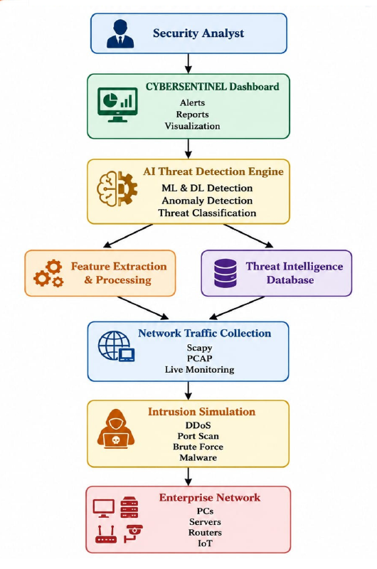
Figure 3.1 System architecture of CyberSentinel XDR

The system operates as an integrated pipeline. A security analyst interacts with the dashboard, while the simulation engine produces attack traffic for the virtual enterprise network. Traffic is processed by the detection engine, persisted through the SQLite repository layer, and propagated to the browser through Socket.IO. Persisted incident data is also used by the automated JSON/TXT reporting module.

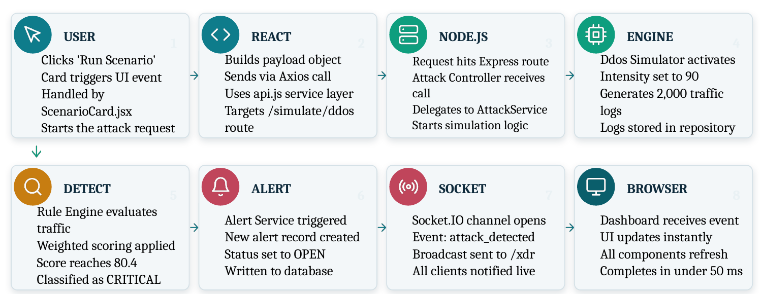
Figure 3.2 Methodology workflow from scenario initiation to live dashboard update.

3.6 Risk Analysis

Design Decision | Alternative  Considered | Benefit | Disadvantage | Final Decision &  Justification
Rule-based scoring | Machine-learning classifier | Transparent and traceable scoring | Less adaptive than trained models | Selected for current scope; ML is future work.
SQLite persistence | PostgreSQL / cloud database | Lightweight and suitable for a single-machine system | Less suitable for large multi-tenant scaling | Selected for current scope; PostgreSQL is future work.
Socket.IO channel | Polling-based dashboard refresh | Push-based updates with <50 ms synchronization | Requires persistent connection | Selected because real-time updates are central to the platform.
Simulated network | Live packet capture | Safe, reproducible and self-contained testing | Does not cover all real-world traffic | Selected for current scope; pcap/NetFlow is future work.

  - Sustainability, Ethics, Safety, Risk & Security

Domain | Consideration | Evidence Evaluated | Impact on Final  Decision
Sustainability | Avoid dedicated enterprise infrastructure for training. | The platform runs on a single machine. | Single-machine architecture retained.
Ethics | Use simulated attacks rather than uncontrolled attacks on real systems. | Five attacks are generated against a virtual 9-node network. | Simulation-only scope retained.
Health & Safety | Avoid unnecessary exposure to real infrastructure during exercises. | Virtual network and internally generated traffic are used. | No production deployment is required.
Security | Maintain complete, quarriable event history and live threat visibility. | Nine repositories, Socket.IO events, alerts and reports are included. | Persistent logging and live visibility retained.

3.7.1 Risk Register

Risk | Likelihood | Severity | Risk Level | Mitigation | Residual  Risk
High-volume simulated traffic may affect single-machine performance | Medium | High | High | Benchmark using the 2,000-log DDoS load and observe pipeline latency. | Medium
Incorrect threat classification | Low | High | Medium | Use weighted scoring and validate accuracy, confidence and true-positive rate. | Low
Loss of event history | Low | High | Medium | Persist events through dedicated SQLite repositories. | Low

CHAPTER 4

IMPLEMENTATION, TESTING & RESULTS, PROJECT MANAGEMENT

  - Development Approach & Resources

Development followed a modular full-stack approach in which the attack simulation engine, detection logic, alerting pipeline, repository layer and dashboard were implemented as separate components. The workflow begins with a React scenario action, passes through an Axios service call to the Node.js/Express backend, invokes the attack service and simulator, evaluates the generated traffic, persists the event and broadcasts the result through Socket.IO. The dashboard then updates in real time and the incident can be exported as JSON or TXT.
  - Hardware / Software / Fabrication Implementation & Modern Tools Used

The implementation is software-only and is intended to operate on a single laptop. The React frontend initiates attack scenarios, while the Node.js backend handles Express routes, controllers and the AttackService. The simulation engine generates attack-specific traffic logs, the detection engine evaluates them, and the SQLite repository layer stores the resulting records.

Tool / Software / Equipment | Purpose | Stage Used
React | Dashboard and scenario interaction | Frontend implementation
Node.js + Express | API routing and backend orchestration | Backend implementation
Axios / api.js | HTTP request handling | Simulation request flow
Socket.IO | Real-time event broadcasting | Detection-to-dashboard pipeline
SQLite | Event and report persistence | Data layer
JSON / TXT reporting | Incident evidence export | Reporting
DdosDetectionRule.js | Weighted detection logic | Detection engine

  - Test Plan & Verification

Verification focused on functional coverage of the five attack simulators, detection scoring, alert creation, real-time event delivery, persistence, report generation and performance under a 2,000-log DDoS burst. The acceptance criteria below are taken from the measurable targets and results reported in the project PPT.

Requirement | Test Method | Acceptance Criterion
Attack simulation | Run each of the five simulation scenarios. | All five attack types generate intended traffic patterns.
Threat scoring | Execute simulated traffic through the weighted Detection Engine. | Threat receives a 0-100 score and severity classification.
Alert generation | Observe the detection-to-alert pipeline. | Alert record is created with OPEN status.
Real-time synchronization | Measure Socket.IO event delivery to browser. | Update completes in <50 ms.

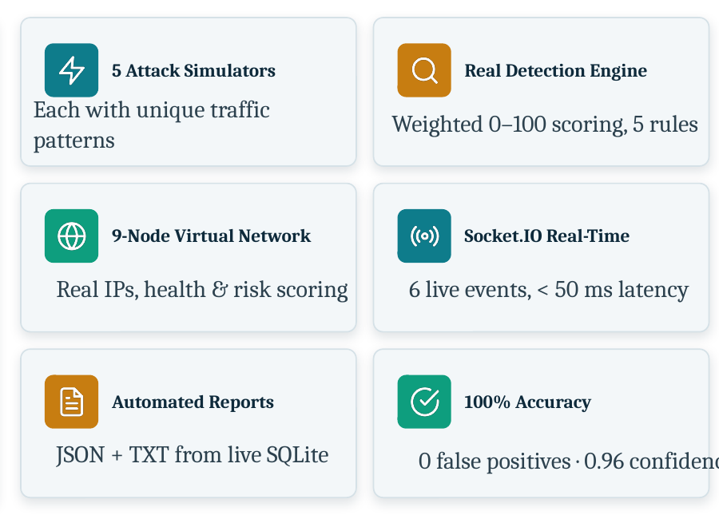
Figure 4.2 Results summary reported in the project presentation.
  - Data Analysis & Engineering Judgment

The presentation contains two accuracy summaries: approximately 90% detection accuracy in the detailed Detection Rule Engine and Performance Analysis slides, and 100% detection accuracy with zero false positives in the Results summary. It also reports a 100% true-positive rate. Because the PPT does not define the denominator or test-set composition for each accuracy figure, this report preserves the values separately rather than combining them into one unsupported metric.

4.5 Data Analysis & Engineering Judgment
The reported measurements show that the system met the principal low-latency objectives under the stated simulation conditions. Socket.IO synchronization remained below 50 ms, attack-to-alert latency remained below 1.2 s, and report generation remained below 2 s. The presentation also states that a 2,000-log DDoS burst produced no measurable degradation across detection, alerting or reporting.

The scoring design is transparent. Four weighted signals are explicitly detailed in the PPT: Traffic Spike (35 points), Flood Intensity (35 points), Source Distribution (20 points) and Attack Intensity (10 points). Together they produce a confidence score out of 100 and a severity classification.

Comparison with Existing Solutions & Achievement of Objectives

Objective | Evidence | Achievement (Fully/Partially/Not  Achieved)
Traffic Spike | 35 pts | Volume of packets relative to normal baseline.
Flood Intensity | 35 pts | Total data throughput during the attack.
Source Distribution | 20 pts | Number of distinct IP sources involved.
Attack Intensity | 10 pts | Configured severity of the simulated attack.

The system operates as an integrated pipeline. A security analyst interacts with the dashboard, while the simulation engine produces attack traffic for the virtual enterprise network. Traffic is processed by the detection engine, persisted through the SQLite repository layer, and propagated to the browser through Socket.IO. Persisted incident data is also used by the automated JSON/TXT reporting module.

  - Assigned Responsibilities

The presentation contains two accuracy summaries: approximately 90% detection accuracy in the detailed Detection Rule Engine and Performance Analysis slides, and 100% detection accuracy with zero false positives in the Results summary. It also reports a 100% true-positive rate. Because the PPT does not define the denominator or test-set composition for each accuracy figure, this report preserves the values separately rather than combining them into one unsupported metric.

Student | Assigned Responsibility | Actual Contribution
Design a 9-node virtual enterprise network and five attack simulators | 9-node network and five attack modules are reported. | Fully Achieved
Develop weighted real-time threat scoring | 0-100 scoring using the explicitly described weighted signals. | Fully Achieved
Implement real-time detection and response | Six Socket.IO event types and <50 ms browser synchronization. | Fully Achieved
Automate JSON/TXT reporting | Report generator exports incident records from live SQLite data. | Fully Achieved
Test accuracy, confidence and latency | 0 false positives, 0.96 confidence, <1.2 s detection latency and <50 ms synchronization are reported. | Fully Achieved

4.7 Strengths & Limitations
4.7.1 Strengths
• Five distinct attack simulators provide different traffic patterns within one controlled environment.
• The Detection Engine uses transparent weighted scoring that can be inspected and explained.
• Socket.IO provides six real-time event types for live dashboard synchronization.
• Nine repositories provide a complete, queryable history of simulation events.
• Automated JSON/TXT reporting reduces manual incident documentation effort.
• The complete platform is designed to operate on a single machine.

4.7.2 Limitations
• The current platform is simulation-based and does not capture genuine production traffic.
• The current detection approach is rule-based rather than adaptive machine learning.
• SQLite and single-machine deployment limit large-scale or multi-tenant operation.
• The PPT does not provide a detailed statistical definition of the reported accuracy values.
• Automated active mitigation is not part of the current implementation.
4.8 Project Planning, Roles & Budget
4.8.1 Project Roles
Student | Assigned Responsibility | Actual Contribution
Vickramabharathi V (192465069) | Attack simulation engine | DDoS, Port Scan and Brute Force simulation modules.
Ram Prasath J (192565021) | Detection rule engine | Weighted rule-based detection and scoring logic.
Abinesh M (192465050) | Real-time pipeline | Socket.IO broadcasting layer and end-to-end latency testing.
Dhanushkumar R (192565087) | Backend persistence | SQLite backend and nine-repository persistence layer.

4.8.2 Budget
Student | Assigned Responsibility | Actual Contribution
Enterprise infrastructure / dedicated security platform | To make simulation environment | Simulation environment checks
Single-machine project environment | To make scoring platform | Simple, Medium, Hard

CHAPTER 5

CONCLUSION, FUTURE WORK AND REFLECTION

  - Conclusion

CyberSentinel XDR is a self-contained, full-stack Extended Detection and Response platform that simulates five attack types against a virtual 9-node enterprise network and detects them live on a single machine. Its Object-Oriented architecture separates attack simulators, detection logic and data repositories into modular components, while Socket.IO provides real-time event delivery to the dashboard. The reported results include five attack simulators, zero false positives, an average confidence of 0.96, sub-50 ms real-time synchronization, sub-1.2 s attack-to-alert latency and sub-2 s report generation. The platform therefore demonstrates a practical, affordable environment for hands-on cyber-defence learning and research under controlled simulation conditions.
  - Future Work
Future Scope | Planned Enhancement
ML-Based Detection | Replace rule weights with a trained Random Forest or LSTM classifier for adaptive, self-learning anomaly detection.
Real Traffic Capture | Integrate live pcap or NetFlow capture so the engine analyses genuine network traffic rather than only simulations.
Cloud-Native Deployment | Containerise with Docker and Kubernetes and replace SQLite with PostgreSQL for large multi-tenant networks.
Automated Response (SOAR) | Add active mitigation such as automatic source-IP blocking, node isolation and firewall-rule triggering for CRITICAL detections.

  - Professional Learning & Individual Reflection

5.3.1 New Knowledge Acquired
• Full-stack integration of a React dashboard with a Node.js/Express backend.
• Object-Oriented modelling of attack simulators, detection rules and repository components.
• Real-time browser communication using Socket.IO event broadcasting.
• Weighted threat scoring and severity classification for simulated network attacks.
• Persistent incident storage and automated JSON/TXT report generation using SQLite.

5.3.2 Engineering & Professional Skills Developed
• Modular software architecture and interface-level integration.
• Test planning, performance benchmarking and interpretation of detection metrics.
• Collaborative development across simulation, detection, real-time communication and persistence modules.
• Technical documentation and presentation of system-level engineering decisions.

5.3.3 Individual Reflection
Vickramabharathi V (192465069)
Role: Attack Simulation Engine. Focused on modular DDoS, Port Scan and Brute Force simulation, including traffic generation and attack-specific behaviour. The project work required modular engineering decisions, testing of the corresponding subsystem and integration with the complete detection-and-response pipeline.

Ram Prasath J (192565021)
Role: Detection Rule Engine. Focused on weighted detection logic and transparent real-time threat scoring. The project work required modular engineering decisions, testing of the corresponding subsystem and integration with the complete detection-and-response pipeline.

Abinesh M (192465050)
Role: Real-Time Pipeline. Focused on Socket.IO broadcasting and end-to-end latency testing. The project work required modular engineering decisions, testing of the corresponding subsystem and integration with the complete detection-and-response pipeline.

Dhanushkumar R (192565087)
Role: SQLite Repository Layer. Focused on SQLite persistence and the nine-repository backend layer. The project work required modular engineering decisions, testing of the corresponding subsystem and integration with the complete detection-and-response pipeline.

REFERENCES
[1] Madeira, J. and Alves, publication details as cited in the project PPT, International Journal of Human-Computer Studies, 2026.

[2] Moura, S., Sasse, M. A. and Thomas, publication details as cited in the project PPT, Behavioural Public Policy, 2026.

[3] Atwater, K., Korolova, A. and Wagner, publication details as cited in the project PPT, IEEE Symposium on Security and Privacy, 2025.

[4] Toth, N., Blythe, J. and Biddle, R., publication details as cited in the project PPT, arXiv, 2025.

[5] Sarker, I. H., Alshaikh, M. and Furnell, S., publication details as cited in the project PPT, Journal of Systems and Software, 2024.

[6] Splunk and CrowdStrike, commercial SIEM/XDR platforms reviewed in the project presentation for enterprise capability and cost baseline.

[7] Socket.IO, real-time event broadcasting technology used in CyberSentinel XDR.

[8] SQLite, lightweight relational database used for project persistence.

APPENDICES

Appendix A - Detailed Calculations
The PPT provides the weighted scoring components as 35 + 35 + 20 + 10 = 100 points. The reported DDoS example reaches a score of 80.4 and is classified as CRITICAL.
Appendix B - Engineering Drawings / Schematics

Figure B.1 System architecture reproduced from the project presentation.

Appendix C - Source Code / Code Repository Information
The project presentation identifies implementation artefacts including ScenarioCard.jsx, api.js and DdosDetectionRule.js. Complete source code is maintained separately from this report.
Appendix D - Experimental / Raw Data
The PPT reports a 2,000-log DDoS burst benchmark, detection score range of 80.4-85.3, average confidence of 0.96, approximately 90% detection accuracy, 100% true-positive rate, zero false positives, sub-50 ms real-time synchronization, sub-1.2 s detection latency and sub-2 s report generat

